**[AI-Based Campus Energy Use Prediction for Assessing the Effects of Climate Change](https://www.mdpi.com/2071-1050/12/8/3223?)**

**Author:**  *Soheil Fathi  , Ravi S. Srinivasan  , Charles J. Kibert  , Ruth L. Steiner  and Emre Demirezen*

**Publication:** *Sustainability*, Volume 12, Issue 8, in 2020.

I have reviewed the paper titled "AI-Based Campus Energy Use Prediction for Assessing the Effects of Climate Change" . This study explores the application of Artificial Intelligence (AI) to predict energy consumption in campus buildings, aiming to enhance sustainability by optimizing resource usage.  
  
The dataset used in the research paper "AI-Based Campus Energy Use Prediction for Assessing the Effects of Climate Change" was collected from buildings at the University of Florida, Gainesville. It includes data on monthly and hourly utility consumption, such as electricity, chilled water, steam, and natural gas. Along with this, environmental data like temperature, humidity, and solar radiation were also recorded to understand their impact on energy use.

**Key Information from the Paper:**

The study aims to develop AI models that can accurately predict short-term energy consumption in campus buildings. With these predictions, universities can take proactive steps to reduce energy waste and adopt more sustainable practices.

To achieve this, researchers used machine learning algorithms, specifically the XGBoost model, to analyze past energy usage data. This helped them identify patterns and detect any unusual spikes in consumption, allowing for more precise forecasting.

The results showed that the AI models were highly accurate in predicting energy use. The XGBoost model performed particularly well, with a root mean square error (RMSE) of 14.72, a mean absolute error (MAE) of 12.00, and a mean absolute percentage error (MAPE) of 2.18%. These findings highlight how AI can play a crucial role in making campuses more energy-efficient and environmentally friendly.

**Model Development:**

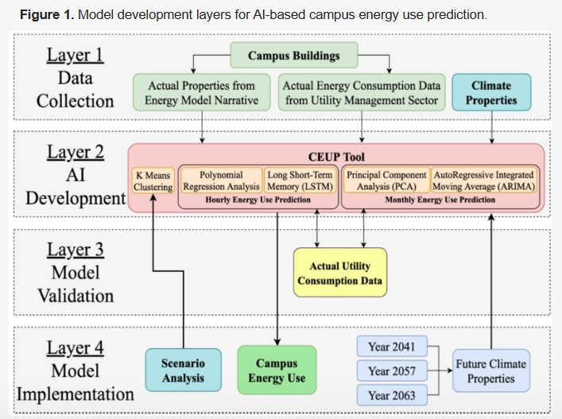

**Dataset Information:**

The study used historical energy consumption data from three campus buildings to train and test the AI models. While the paper doesn’t provide the exact structure of the dataset, such datasets typically include details like:

* Building ID – Identifies the specific campus building
* Timestamp – Records the date and time of energy usage
* Energy Consumption (kWh) – Measures the amount of energy used
* Additional Factors – Includes things like temperature, humidity, and occupancy levels, which can impact energy use

Here’s an example of how the dataset might be structured:

|  |  |  |  |
| --- | --- | --- | --- |
| **Building ID** | **Timestamp** | **Energy Consumption (kWh)** | **Additional Factors** |
| Bldg_1 | 2024-01-01 00:00:00 | 150 | 22°C, 80% occupancy |
| Bldg_1 | 2024-01-01 01:00:00 | 145 | 21°C, 75% occupancy |
| Bldg_2 | 2024-01-01 00:00:00 | 200 | 20°C, 60% occupancy |
| Bldg_3 | 2024-01-01 00:00:00 | 180 | 19°C, 50% occupancy |

Note: This dataset is a hypothetical representation based on the details mentioned in the research paper. Since the paper doesn’t provide the exact dataset structure, I designed it using common data points that are typically included in energy consumption studies. I considered key factors like building ID, timestamps, energy usage (in kWh), and external influences such as temperature and occupancy. This structure follows the logical framework used in AI-based energy forecasting models, helping to understand how AI can optimize campus energy efficiency.